TumorSynth: Integrated Brain Tumor and Tissue Segmentation in Brain MRI Scans of any Resolution and Contrast

Figures 5 Revised

Main Body

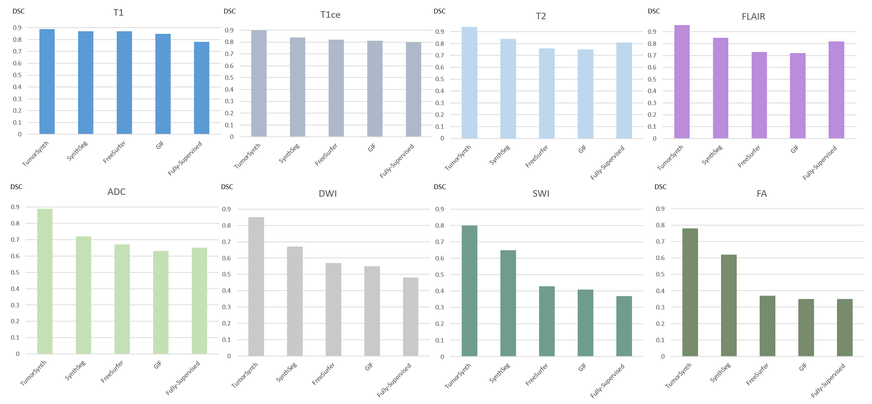
Figure 5. Comparison of cross-modality performance average for brain tissue segmentation using subjects with tumors across five tools—TumorSynth, SynthSeg, FreeSurfer, GIF and Fully-Supervised model, while the y-axis is the DSC metrics. Only one input sequence was provided for each inference for this test, and zero padding was used when other input sequences were missing. TumorSynth is trained on T1, T1ce, T2, FLAIR and domain randomized images and cross-validated on the other 4 modalities (apparent diffusion coefficient (ADC) maps, diffusion weighted imaging (DWI), susceptibility weighted imaging (SWI) and Fractional Anisotropy maps (FA)); SynthSeg is trained on T1 and synthetic contrast images, cross-validated on the other 7 sequences; FreeSurfer and GIF are designed for T1 images while validated on other sequences as well in this experiment; Fully-Supervised model is trained with multi-modality on T1, T1ce, T2 and FLAIR and used exactly the same real scans as used in the TumorSynth training, however it requires full sequence to perform the inference, resulting in unsatisfactory performance in some situations. Mean dice similarity coefficient results are provided.

