FreeSurfer Course- Boston, April 2018

Table of Contents

Part 1: Reading
- FreeSurfer Introduction
  - What is it and what can it do?
  - Basic concepts - structural pipeline
  - Measures to use for analyses
  - Papers
- MRI Resources
- Neuroanatomy Resources

Part 2: Homework
- Navigating the command line

Part 1: Reading

CHAPTER 1 FreeSurfer Introduction

1.1 What is FreeSurfer and what can it do?

FreeSurfer is a software package for the analysis and visualization of structural and functional neuroimaging data from cross-sectional or longitudinal studies. It was developed by the Laboratory for Computational Neuroimaging at the MGH/HST Athinoula A. Martinos Center for Biomedical Imaging.

Structural MRI
FreeSurfer provides a full processing stream for structural MRI data, including:
- Skull stripping, B1 bias field correction, and gray-white matter segmentation
- Reconstruction of cortical surface models (gray-white boundary surface and pial surface)
- Labeling of regions on the cortical surface, as well as subcortical brain structures
- Nonlinear registration of the cortical surface of an individual with a stereotaxic atlas
- Statistical analysis of group morphometry differences
- Longitudinal steam

Functional MRI
The main functional processing method is FS-FAST (FreeSurfer Functional Analysis STream), a set of tools used to perform functional data analyses on the cortical surface.

Diffusion MRI
TRActs Constrained by UnderLying Anatomy (TRACULA) is a tool for automated global probabilistic tractography with anatomical priors. It reconstructs a set of major white-matter pathways by incorporating prior information from the structural segmentation labels that each pathway goes through or next to, as a function of position along the length of the pathway. It includes a specialized stream for processing longitudinal diffusion MRI data.

PET MRI
PETSurfer is a tool for performing ROI-based, surface-based, and whole-brain analysis of PET data integrated with FreeSurfer anatomical analysis.

Multimodal
FreeSurfer comes with a variety of different tools for both within-subject and across-subject image registration.

1.2 Basic concepts of the FreeSurfer structural processing pipeline

To understand the utility of FreeSurfer in analyzing brain imaging data, it is important to first understand the processing pipeline and important outcome measures. This reading will introduce you to these concepts and touch upon some key terminology (in italics) used during the course.

Below we describe what FreeSurfer does and how it does it. A more technical description of the structural Freesurfer processing pipeline is located here and in the papers mentioned in section 1.4: https://surfer.nmr.mgh.harvard.edu/fswiki/FreeSurferAnalysisPipelineOverview

FreeSurfer creates computerized models of the brain from MRI data. It takes a T1-weighted (MPRAGE) image, 1mm isotropic, as it’s main input. The output of the standard processing pipeline (called recon-all) is a completely anatomically segmented brain with surfaces delineating the cortex.

To put it simply, there are two major components of structural data processing using FreeSurfer: volumes and surfaces. A volume means a 3-D data set that typically contains either intensity information derived from the original MRI, or the results of segmenting this data into tissue classes. A surface generally means a reconstructed boundary.

The structural processing pipeline divides the brain up into the different anatomical regions/classes/parts that you care about so that you can measure them. The term segmentation, in general, refers to the classification of the brain into different tissue classes based on anatomy. The structural processing pipeline produces many volumes as outputs, some of which are segmentations of different parts of the brain. Arguably the most important is the aseg volume- this is an automatic volumetric segmentation (aseg) of the cortex and subcortical structures. The cortex is the outer layer of neural tissue of the cerebrum, composed of folded gray matter (red, in the image below). Subcortical literally means "below the cortex”, so subcortical structures could be defined liberally as everything beneath the cortex or more conservatively as a set of certain structures in the forebrain, midbrain, and hindbrain. In the aseg volume, subcortical structures are divided into white matter and grey matter structures (basal ganglia, limbic structures, thalamus, etc). In FreeSurfer, we only use the term segmentation to refer to subcortical classification. (We use a different term for cortical classification, which we will describe below.)

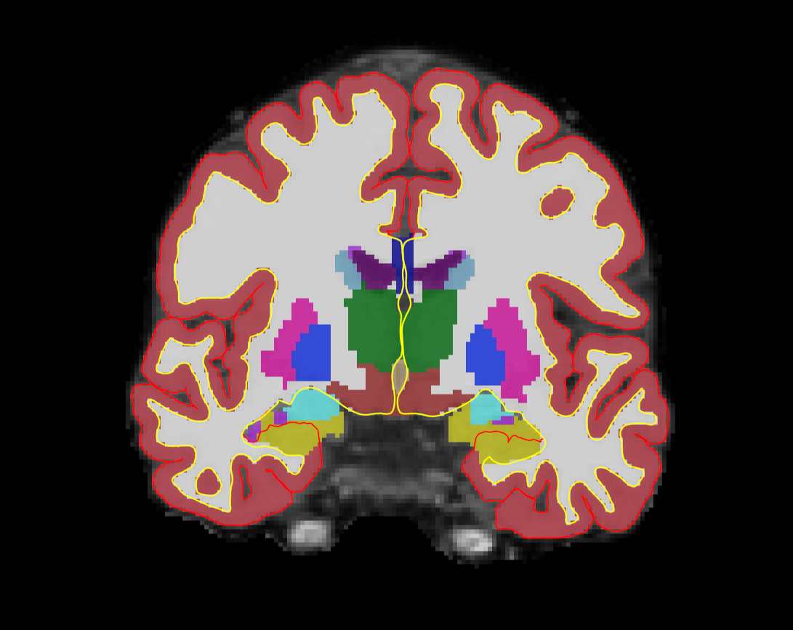
Image of the aseg volume showing cortex (red), white matter (white), and subcortical structures (various colors). White and pial surfaces are displayed as yellow and red lines, respectively.

The next part of the FreeSurfer processing pipeline is ‘cortical surface reconstruction’. There are two surfaces created by the FreeSurfer processing pipeline: cortical (aka pial) and white. The pial surface is the boundary between the edge of the cortex (grey matter) and cerebrospinal fluid- it is the outermost layer of the brain. Ideally, this surface lies above layer I and below the pia mater (see Fischl, 2012). The white surface is the boundary between the outermost layer of white matter and the innermost layer of grey matter (the most interior layer of cortex). The surfaces therefore define the inner and outer layers of the cortex.

FreeSurfer can further divide the cortex and white matter into different anatomical regions to be measured. Two more volumes are created along the processing stream- the automatic parcellation of cerebral cortex, otherwise known as aparc, and the parcellation of the white matter, wmparc. Similarly to segmentation, parcellation is another term for division. The parcellation of the cortex is based on Brodmann’s areas, but you could use another atlas or create your own.

After running the structural pipeline recon-all, you can then run other processing pipelines available through FreeSurfer, such as FS-FAST.

1.3 Measures to use for analyses

After the processing pipeline finishes successfully, you’re left with output files that allow you to analyze your data in several ways. These outputs can be found in the mri, surf, label and stats folders of each subject (data organization will be covered during the course). Some important files used for data analysis are listed below:

Automatically produced files
*Note: ?h refers to either hemisphere. For instance, rh.pial is the pial surface on the right hemisphere.
- MRI folder
  - orig.mgz: This is the original volume conformed to 1mm isotropic resolution.
  - T1.mgz: The orig volume after intensity normalization has occurred.
  - brainmask.mgz: The T1 volume after the skull and other non-brain structures have been removed.
  - wm.mgz: A volume that labels everything in the brain that is not cortex. This predominately consists of white matter.
  - wmparc.mgz: A volume displaying the automatically generated white matter segmentation
  - aseg.mgz: A volume displaying the automatically generated labels of grey matter, white matter and subcortical structures
- Label folder
  - aparc.annot: parcellation of the cortical surface
- Surf folder
  - ?h.pial
  - ?h.white
  - ?h.thickness: cortical thickness file containing information on the distance between white and pial surfaces
  - ?h.inflated: white matter surface inflated so that you can visualize all sulci and gyri
- Stats folder
  - ?h.curv.stats: summary file of cortical curvature statistics
  - ?h.aparc.stats, ?h.aparc.a2009s.stats, ?h.aparc.DKTatlas.stats: the command mris_anatomical_stats creates a summary table of cortical parcellation statistics for each structure.
  - aseg.stats: recon-all computes statistics on the segmented subcortical structures found in mri/aseg.mgz.
  - ?h.w-g.pct.stats: recon-all computes the vertex-by-vertex percent contrast between white and gray matter.

This section has reviewed the core elements of the FreeSurfer structural processing stream, but FreeSurfer’s functionality extends far beyond this topic. We will go over some of additional features during the course.

1.4 Papers and more information

For more detailed information, please visit: https://surfer.nmr.mgh.harvard.edu/fswiki/FreeSurferWiki

Or read the following five papers:
1) Fischl, B. (2012). FreeSurfer. NeuroImage, 62(2), 774–781. http://doi.org/10.1016/j.neuroimage.2012.01.021
https://www.ncbi.nlm.nih.gov/pmc/articles/PMC3685476/

2) Fischl B, van der Kouwe A, Destrieux C, Halgren E, Ségonne F, Salat DH, Busa E, Seidman LJ, Goldstein J, Kennedy D, et al. Automatically parcellating the human cerebral cortex. Cereb Cortex. 2004;14 (1) :11-22.
https://surfer.nmr.mgh.harvard.edu/ftp/articles/fischl04-parcellation.pdf

3) Dale, A.M., Fischl, Bruce, Sereno, M.I., (1999). Cortical Surface-Based Analysis I: Segmentation and Surface Reconstruction. NeuroImage 9(2):179-194
https://surfer.nmr.mgh.harvard.edu/ftp/articles/dale99-recon1.pdf

4) Fischl, Bruce, Sereno, M.I., Dale, A.M., (1999). Cortical Surface-Based Analysis II: Inflation, Flattening, and a Surface-Based Coordinate System. NeuroImage 9(2):195-207
https://surfer.nmr.mgh.harvard.edu/ftp/articles/fischl99b-recon2.pdf

5) Fischl B, Salat D, Busa E, Albert M, Dieterich M, Haselgrove C, van der Kouwe A, Killiany R, Kennedy D, Klaveness S, Montillo A, Makris N, Rosen B, Dale A.M.. Whole brain segmentation. Automated labeling of neuroanatomical structures in the human brain. Neuron. 2002; 33(3): 341-355
https://surfer.nmr.mgh.harvard.edu/ftp/articles/fischl02-labeling.pdf

CHAPTER 2 MRI Resources

1) https://www.youtube.com/watch?v=Ok9ILIYzmaY
- important concepts include: MRI, T1, T2, T2*, k-space

2) http://pubs.rsna.org/doi/full/10.1148/rg.254055027
- important concepts include:T1, T2, TE, TR, pulse sequences

CHAPTER 3 Neuroanatomy Resources

1)http://homepage.smc.edu/russell_richard/Psych2/Graphics/human_brain_directions.htm
- Learning directions of the brain (anterior, posterior, inferior, superior, etc.)

2) http://www.neuroanatomy.ca/MRIs/mri_coronal.html?id=1
- Example MRI coronal slices

3) http://www.radiologyassistant.nl/en/p48f4c4ccd9682/brain-anatomy.html
- Example MRI axial slices
Part 2: Homework

The following exercises should be completed before the first course day. Completing these exercises ahead of time will prepare you for working with FreeSurfer via the command line and will test your knowledge on key FreeSurfer concepts. We hope that these exercises will provoke questions and give you a better idea for which concepts you need more practice on.

Navigating the command line
Adapted from the following page: https://surfer.nmr.mgh.harvard.edu/fswiki/FsTutorial/CommandLineNavigation?highlight=%28command%29%7C%28line%29

The majority of FreeSurfer tools are command-line based. This exercise will touch upon a few basic commands that will help you navigate the command-line environment. FreeSurfer runs from your computer’s ‘terminal’- a terminal gives you access to your computer via typing commands rather than clicking the mouse.

To begin practicing in a terminal, either open a terminal on your computer (usually in ‘applications’ or ‘programs’) or go to this page:
https://www.tutorialspoint.com/unix_terminal_online.php
If you went to the online terminal, your screen will look like this:
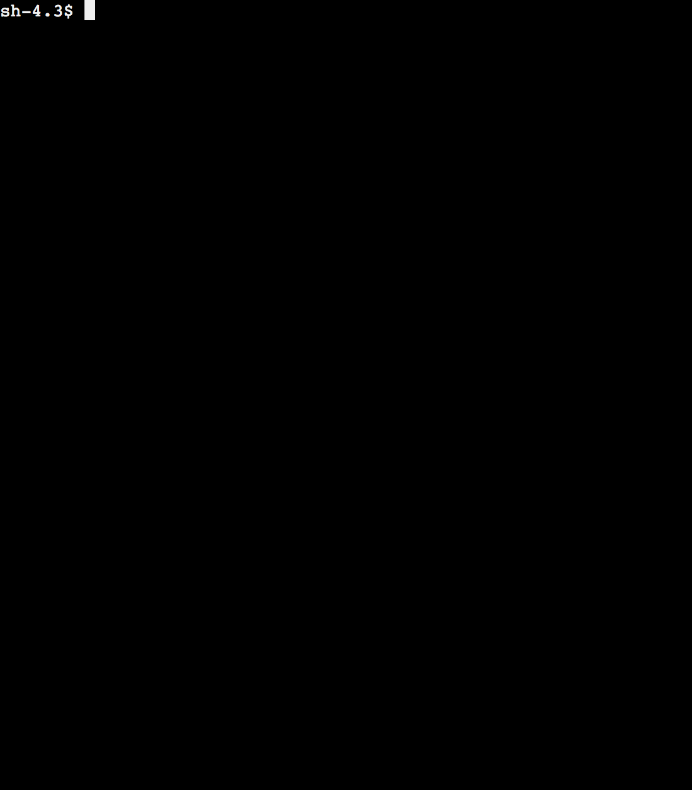
Type ls in the command line:
You should see this output:
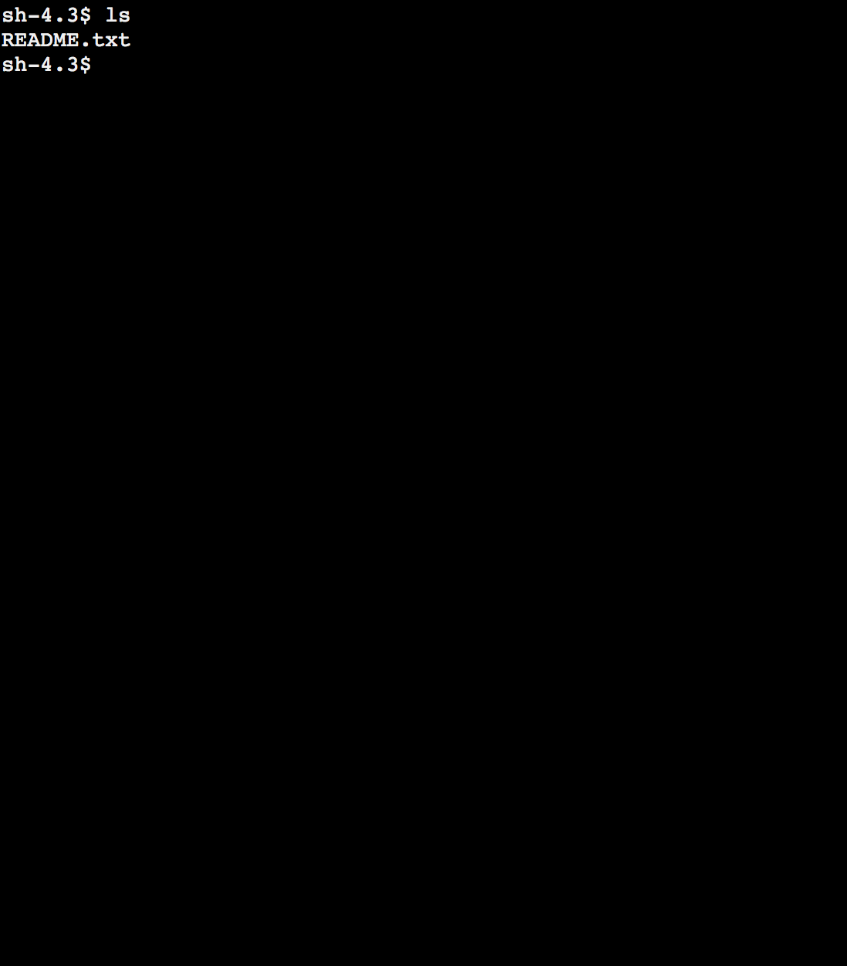

Judging by its file extension (.txt), README is a simple text file that can be read in your terminal or with a text editor. Type:
more README.txt
You can press the ‘tab’ key after typing a few letters of README.txt to complete the file name. This is used to save time and shorten typing.
Your screen should look like this:

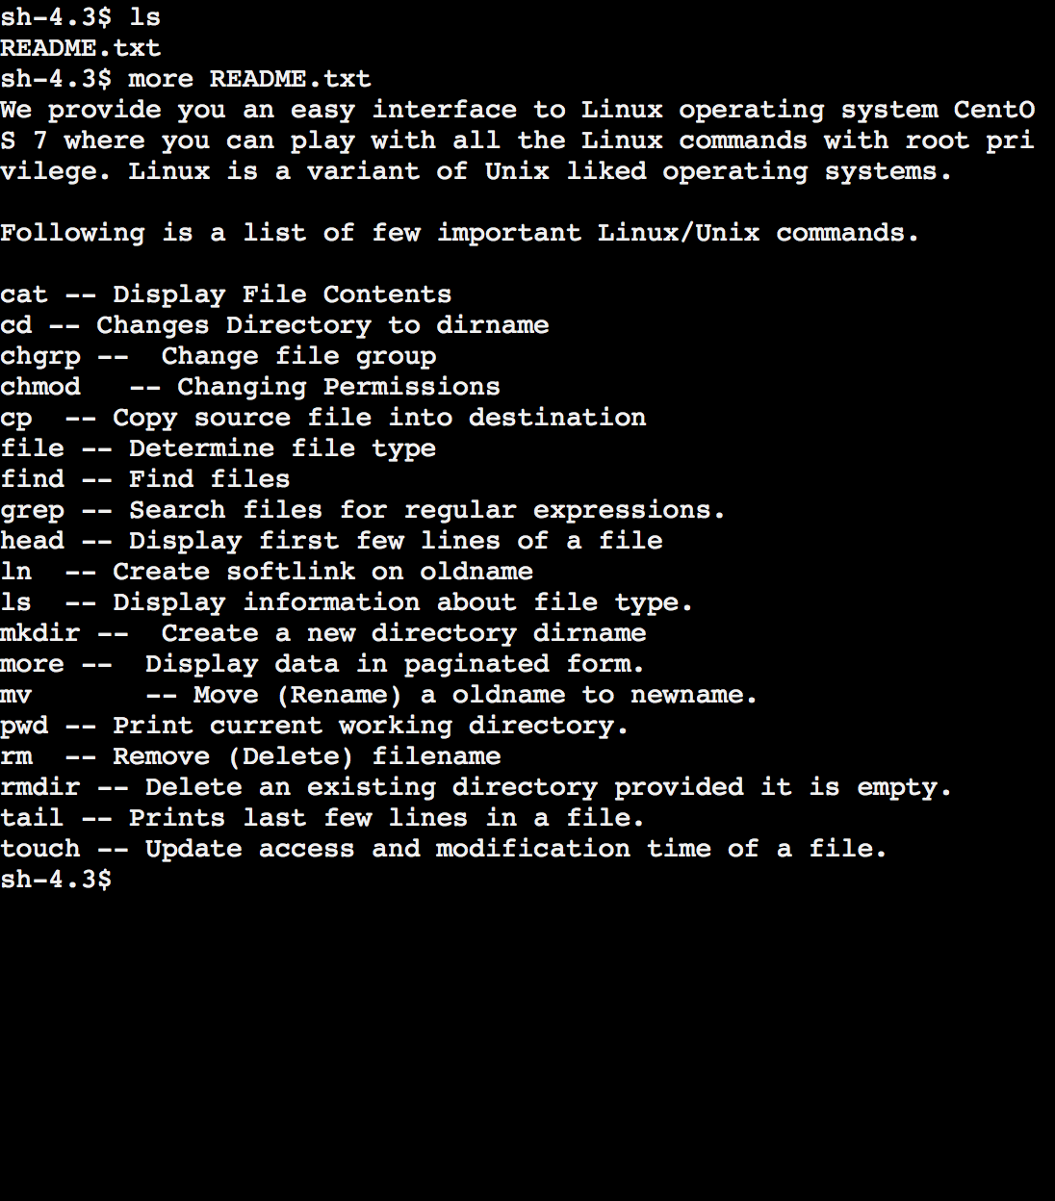

The file README.txt lists some commands used to navigate the linux environment. These commands are not specific to FreeSurfer- all terminal environments will understand these commands. Try the following, using the commands provided by README.txt:
more README.txt | grep Display
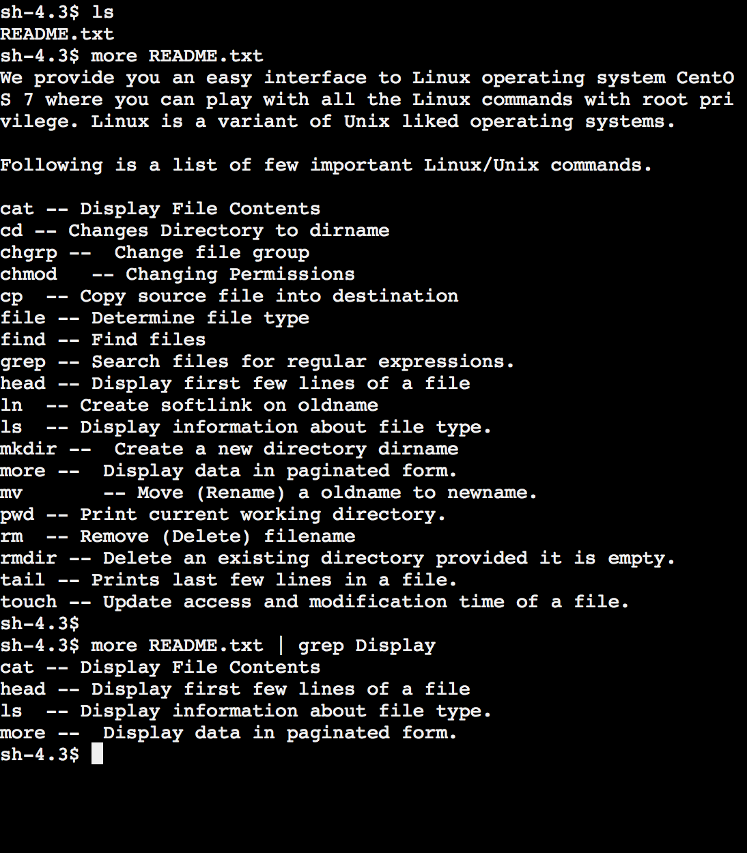

This symbol ( | ) is known as a pipe, and it separates two programs on a command line. The output of the first part of your command (more README.txt) is used as the input for the second part of your command (grep Display). So, the command ‘grep’, which searches through text for a specified character, knows to search through the entire file ‘README.txt’ and output all lines with the word ‘Display’ in your terminal. This is useful when searching through lengthy FreeSurfer documentations. In your terminal, you can do so by typing the FreeSurfer command of interest followed by --help

If you want to save a copy of README.txt, type the following:
cat README.txt > copy.txt

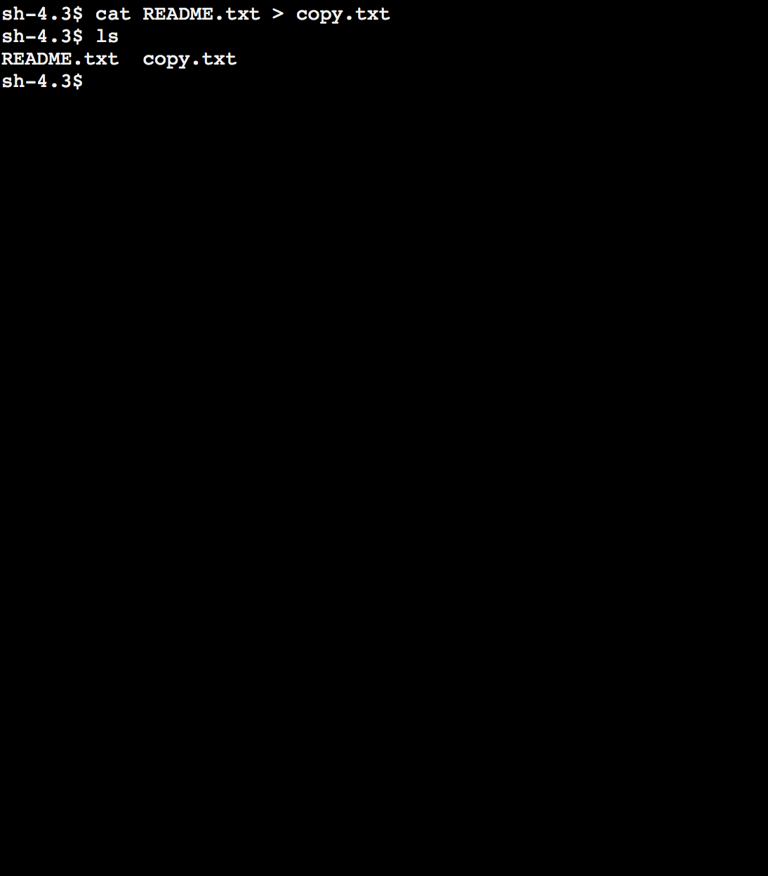

If you want to rename it, type:
mv copy.txt README_copy.txt
ls

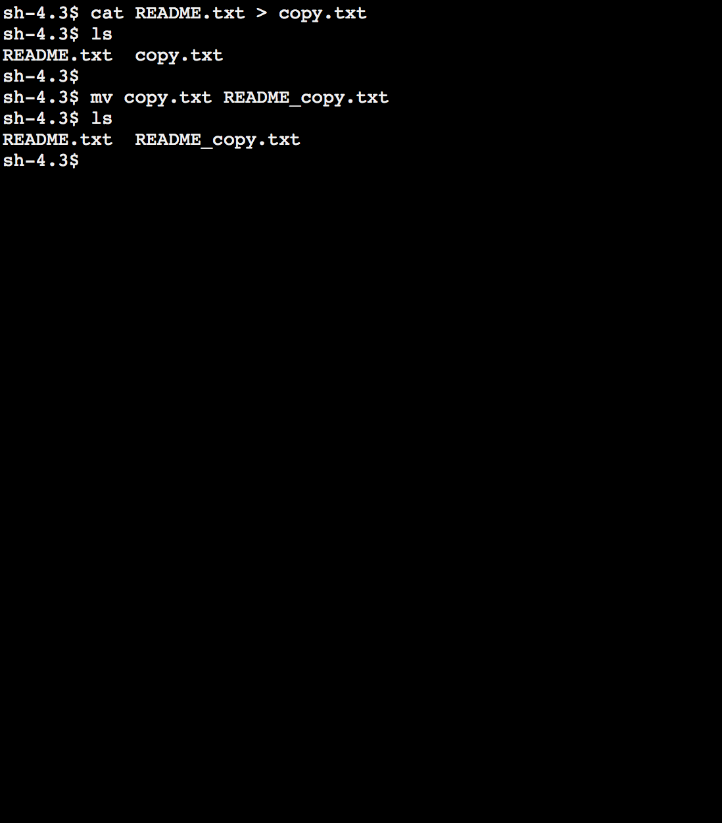

If you want to see who can access your files/directories (called permissions), when your files were created, and the size of the files, type:
ls -l
Your output will look like this. Use the chmod command to alter group permissions.
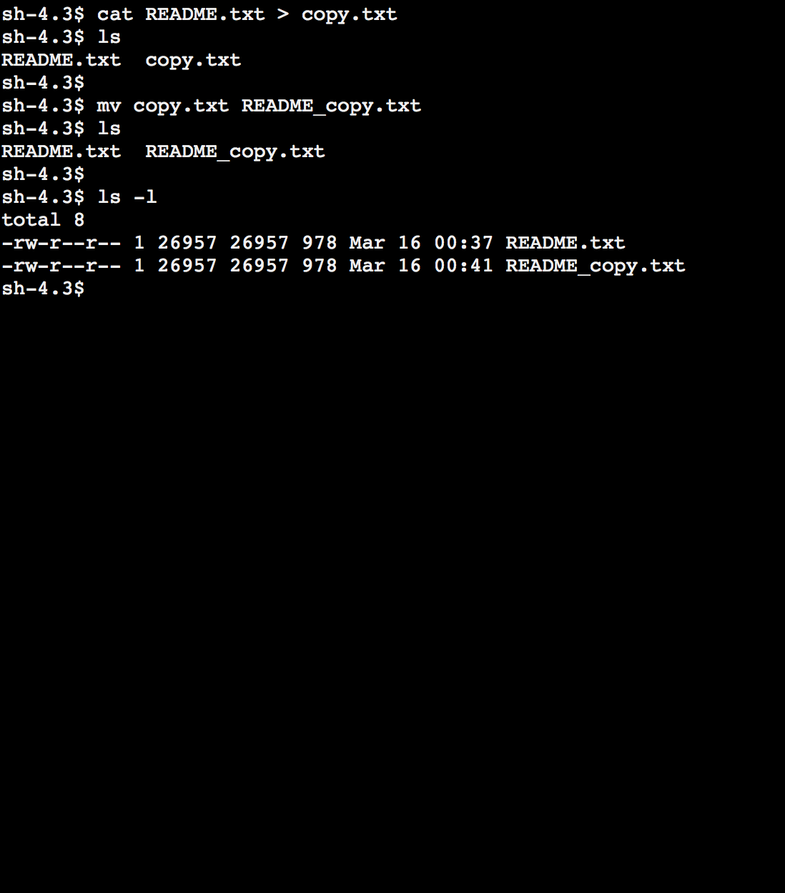

In addition to manipulating text files, you can also manipulate directories (otherwise known as ‘folders’). As an example exercise, type:
mkdir mri
ls
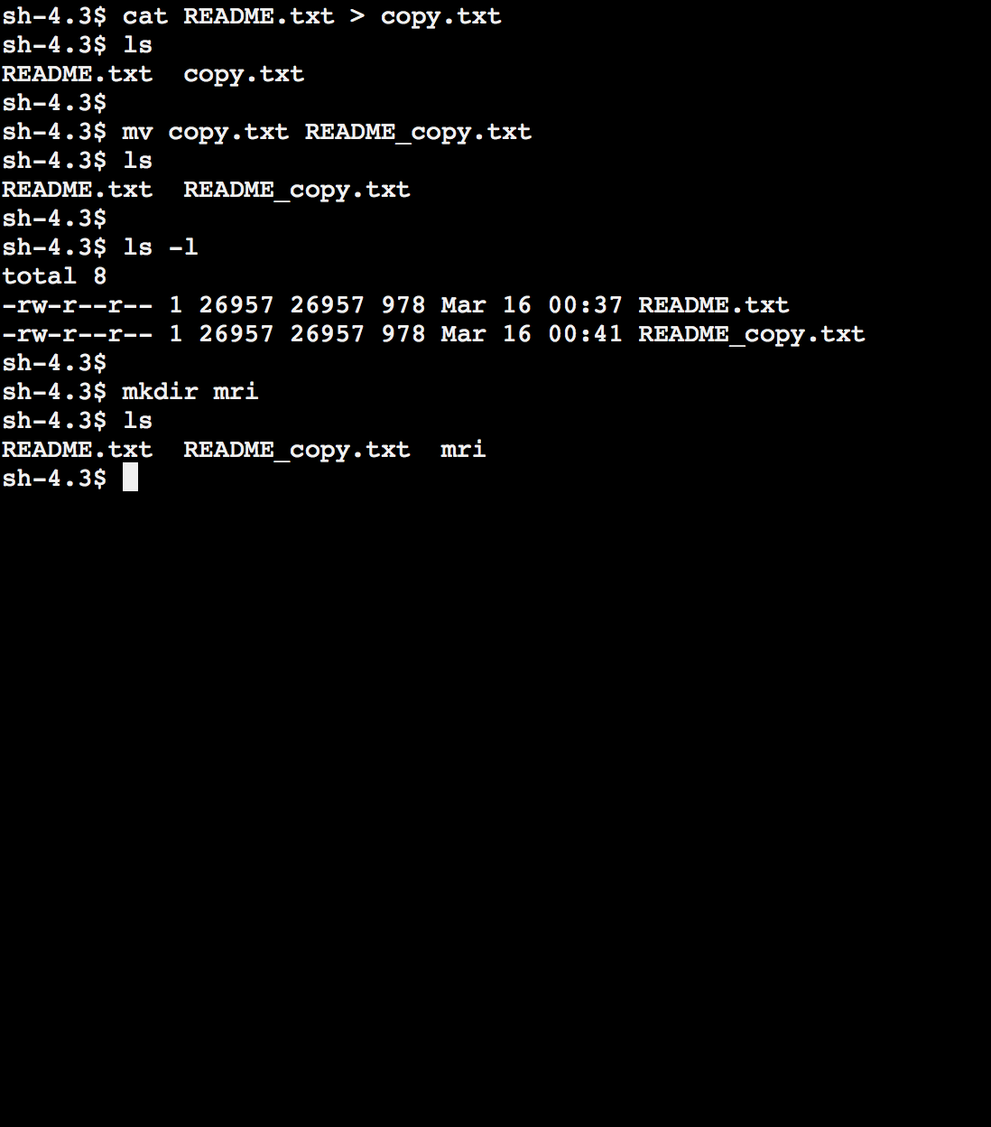

This will create an ‘MRI’ directory under your current working directory. When you use the FreeSurfer processing pipeline (by running recon-all), an MRI directory is created for you with all of your files. The following directories are also created: scripts, label, surf and stats. You will work more with the FreeSurfer directory structure on the first day of the FreeSurfer course. You can see where you are currently ‘working’ (which directory you are currently in) by typing pwd. This command will give you a ‘path’ to your location (see below).
If you wanted to be working inside the MRI directory, type cd first. This command stands for ‘change directory’.

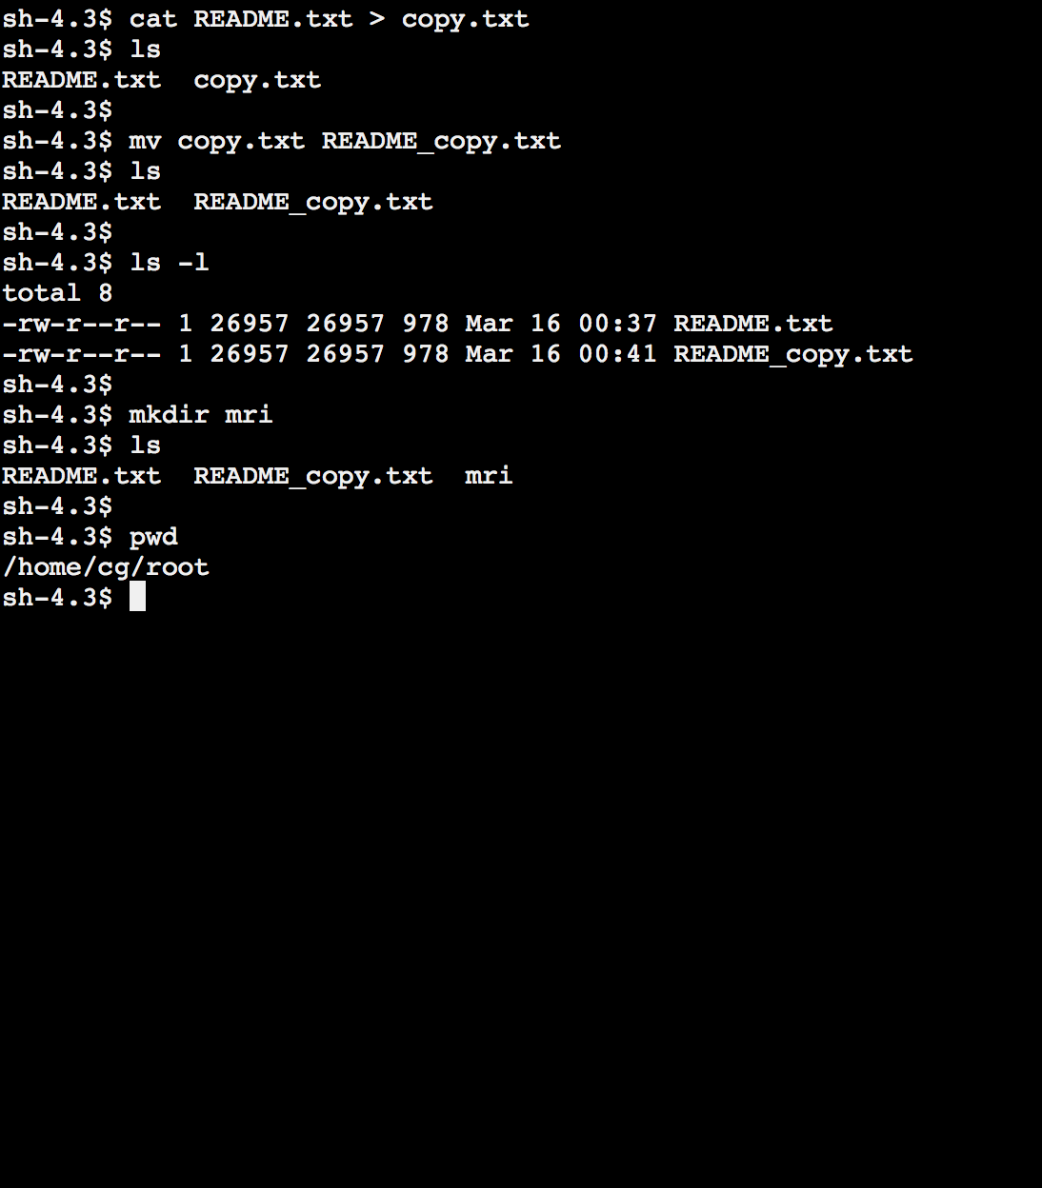

Once FreeSurfer is installed many more commands will be available for you to use. So far, we have not touched on any FreeSurfer-specific commands.
Before running FreeSurfer, certain variables must be set in order to use it correctly. These variables are called ‘environmental variables’. Below are two environmental variables that need to be set, but do not try setting them until the course (you will receive an error message on your terminal, since FreeSurfer is not installed).
export FREESURFER_HOME=/location/of/freesurfer
source $FREESURFER_HOME/SetUpFreeSurfer.sh
export SUBJECTS_DIR=/location/of/your/data

The first command will tell your terminal where the FreeSurfer software is located. The source command sets up your FreeSurfer environment. The variable SUBJECTS_DIR will be the location of the data you are currently working with. You must reset SUBJECTS_DIR every time you are working with a new set of data, and whenever this data is saved in a new location on your computer.

To set a local variable, type:
myFirstVariable = 20
To check the value you have set a variable to, use the command echo. In the above example, to check the value of ‘myFirstVariable’, type:
echo $myFirstVariable

So far, you have learned the following commands:
ls (including -l flag)
more
grep
cat
mv
mkdir
pwd
cd
export

Now try using some of these commands on your own, along with the others provided in the file README.txt.

Navigating the terminal and command line may seem daunting for beginners. Using FreeSurfer via the command line may seem even more difficult. To alleviate any worries, the FreeSurfer developers created plenty of documentation available for you. On the first day of the course, there will be a Linux interactive talk and tutorial. Throughout the course, there will be plenty of FreeSurfer experts around to answer questions. On your own, you can also familiarize yourself with the documentation for FreeSurfer specific commands at the following website:
https://surfer.nmr.mgh.harvard.edu/fswiki/ReconAllTableStableV6.0

All FreeSurfer commands come with instructions- if you type command - - help in your terminal, you will see how to run the command, the special -flag options it includes, and some information on what the command does.

